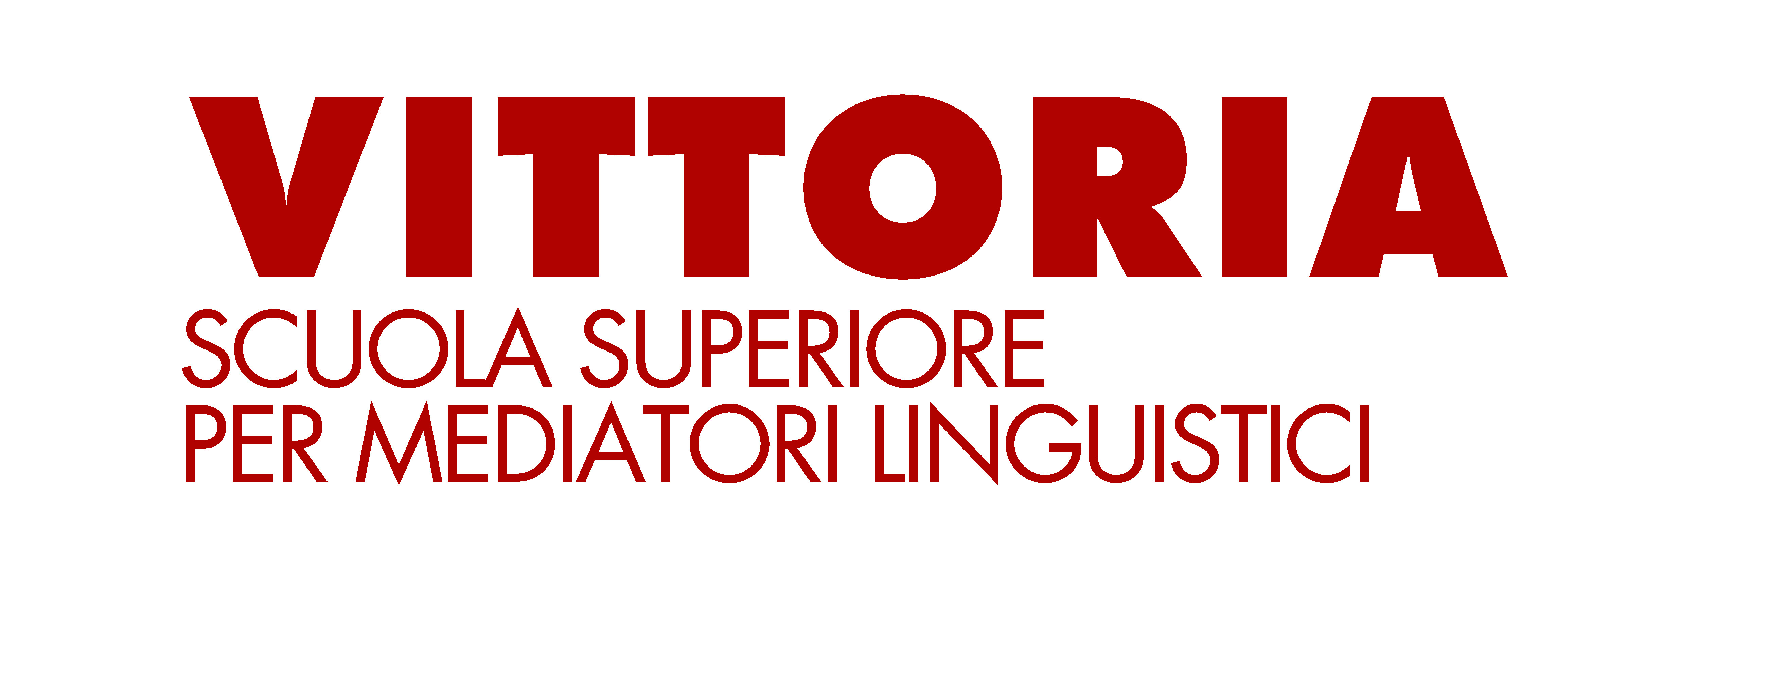

|  |  |
| --- | --- |
| COURSE TITLE | TECHNOLOGIES FOR TRANSLATION AND INTERPRETING |
| DEGREE PROGRAM | LM-94 (MASTER’S DEGREE) |
| ACADEMIC YEAR | 2024-2025 |
| YEAR OF STUDY |  |
| CREDITS (CFM) |  |
| SDS (Scientific Disciplinary Sector) |  |
| TUITION HOURS | 12 |

|  |  |
| --- | --- |
| COURSE TUTOR | Mauro Pistoi |
| E-MAIL ADDRESS | mauro.pistoi@ssmlto.it |

|  |  |
| --- | --- |
| **OBJECTIVES** | Students will be able to use certain computer technologies and software necessary for the work of a translator or interpreter, and independently evaluate the resources and tools available on the Internet. |

|  |  |
| --- | --- |
| **CONTENTS** | Given the brevity of the course and assuming basic IT knowledge, an overview of the technological resources available to interpreters and translators will be presented. In particular, in addition to a theoretical introduction to the subject, tools and techniques for terminology extraction and analysis of specialized corpora will be explored. Special attention will be given to the analysis of parallel texts compared with the results obtainable through machine translation and AI. |

|  |  |  |  |  |
| --- | --- | --- | --- | --- |
| EVALUATION | | | | |
| Final exam | X | Continuous assessment |  |  |
| Type of test: |  |  |  |  |
| WRITTEN | X | ORAL |  |  |

|  |
| --- |
| BIBLIOGRAPHY |

|  |  |
| --- | --- |
| Author | Cabré M.T. |
| Title | “Terminology: Theory, methods and applications” |
| Publisher | John Benjamins Publishing Co |
| Published in | 1999 |

|  |  |
| --- | --- |
| Author | Magris M., Musacchio M. T., Rega L., Scarpa F. |
| Title | “Manuale di terminologia, Aspetti teorici, metodologici e applicativi” |
| Publisher | Hoepli |
| Published in | 2002 |

|  |  |
| --- | --- |
| Author | Fantinuoli C. |
| Title | "The use of comparable corpora in interpreting practice and teaching" |
| Publisher | The Interpreters' Newsletter 23, 133-149 |
| Published in | 2018 |

|  |  |
| --- | --- |
| Author | Fusi D. |
| Title | “Tecnologie informatiche per l’umanista digitale” |
| Publisher | Edizioni Nuova Cultura |
| Published in | 2017 |